THEME
5 v 5 + 3 Possession with Transition

DESCRIPTION OF PRACTICE (TECHNIQUE / SKILL)
A functional practice designed to improve players passing, movement, awareness of space and decision making with transition to defend

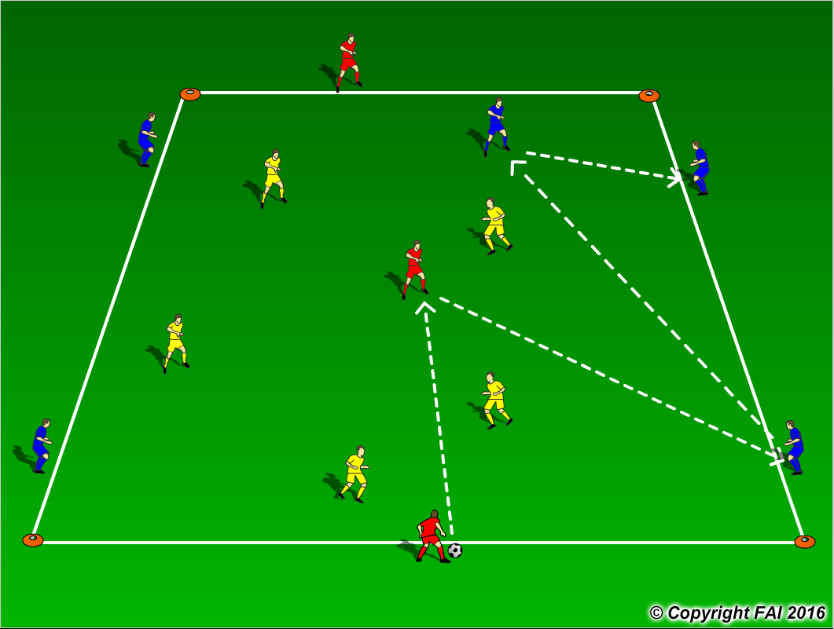

ORGANISATION
- Area: 40 x 30 metres
- 5 Blue Players v 5 Yellow Players + 3 Red Players (Link Up Players)
- Objective of both teams is to keep possession of the football using the Red players
- Team in possession, i.e. (Blue Players as seen above in diagram) must stay in shape above to keep passing angles with one Player playing inside the area
- If the Yellow Players win the ball, they must quickly transition to attack and now get in the shape the Blue Players were in
- If the Blue Players give the ball away, they must quickly transition to defend and win the ball back with all five Players now inside the area
- Coach to have a supply of footballs to keep the practice continually flowing

KEY FACTORS
- Quality and selection of pass
- Body shape/Receive on Back Foot /First Touch
- Angles and Distance of support
- Awareness of space and defender
- Communication between players
- Transition to Defend – can we win ball back as quickly as possible?
- Transition to Attack – can we now keep possession and get in shape as quickly as possible?
- Pressure when defending – can we force opposition into making a mistake?

NOTES
If players of high ability encourage two touch to create good intensity and quick thinking

