THEME
Possession and Finishing 2 v 2 + 1 + 4

DESCRIPTION OF PRACTICE (TECHNIQUE / SKILL)
A functional practice designed to improve players short passing with ball control, speed around the pitch and finishing with transition to defend

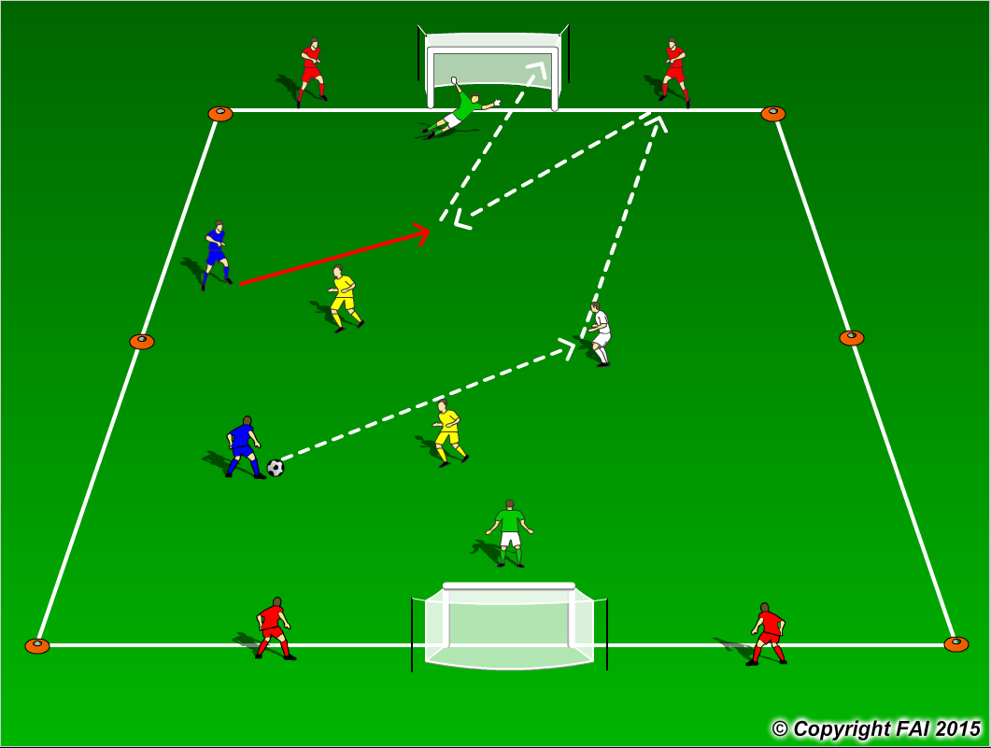

ORGANISATION
- Area: 25 x 20 metres
- 2 Blues v 2 Yellows + 1 White (neutral player) + 4 Reds (wall players) + 2 Goalkeepers
- Objective of both teams is to move the ball quickly around the playing area with speed and efficiency, exploiting the attacking opportunities that arises
- White player is with the team in possession at all times, while in order to score the team in possession must play a wall pass with a Red player on the outside, either side of the goal
- 2 minutes playing time with a 45 seconds rest. Coach during rest period (Active Rest)
- Have Footballs on the side to keep practice at a high intensity

KEY FACTORS
- Quality and selection of pass
- Ball control/Body shape/first touch/back foot
- Angles and Distance of support
- Awareness of space and defender
- Movement and communication
- Finishing
- Transition to Defend – can we win ball back as quickly as possible?
- Transition to Attack – can we now attack as quickly as possible?

NOTES
Demand high quality – practice must be played at speed, i.e. passes and movement. If players of a high ability play two touch.

