THEME
1 v 1 Situations – Attacking Out Wide and Switching The Play in The Final Third

DESCRIPTION OF PRACTICE (TECHNIQUE / SKILL)
A functional practice designed to improve players passing, dribbling, movement and finishing with transition to defend

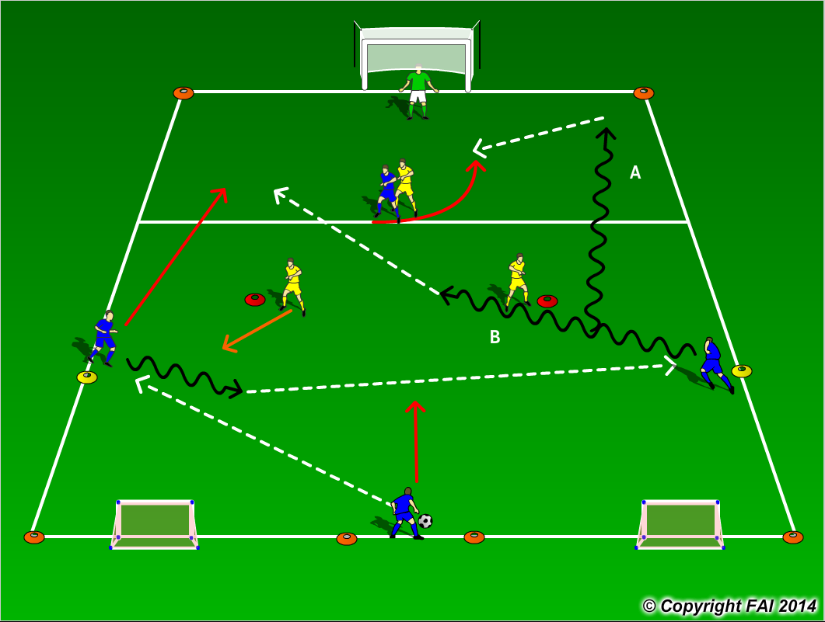

ORGANISATION
- Area 40 x 35 metres
- 4 Blues v 3 Yellows + 1 Goalkeeper
- Blue Team starts with possession
1 – Center Midfielder passes to Wide Left (11)
2 – Wide left dribbles inside and switches the play to Wide Right (7)
3 – Wide Right goes 1 v 1 against Yellow defender going either way as shown in the diagram
4 – Final product? i.e. pass to Forward (9) or try score themselves
- Center Midfielder to stay central and drop a bit, provide defensive cover.
- If the Yellow team win possession can they transition to attack and score in either one of the two small, can Blue team transition to defend quickly?

KEY FACTORS
- Dribbling 1 v 1, .i.e. skills/feints to beat an opponent
- Quick acceleration while dribbling
- Quality and selection of pass
- Movement and communication
- Finishing
- Quick transition in both attack and defense

NOTES
Let the practice run freely. Make sure that players play till goal is scored, i.e. a goal is scored at either end, or ball goes out of play and are aware of the transitions. If players of good quality give them time limit to score

