THEME
7 v 7 Small Sided Game

DESCRIPTION OF PRACTICE (TECHNIQUE / SKILL)
7 v 7 Small Sided Game designed to improve players all round Technique and Tactical Awareness

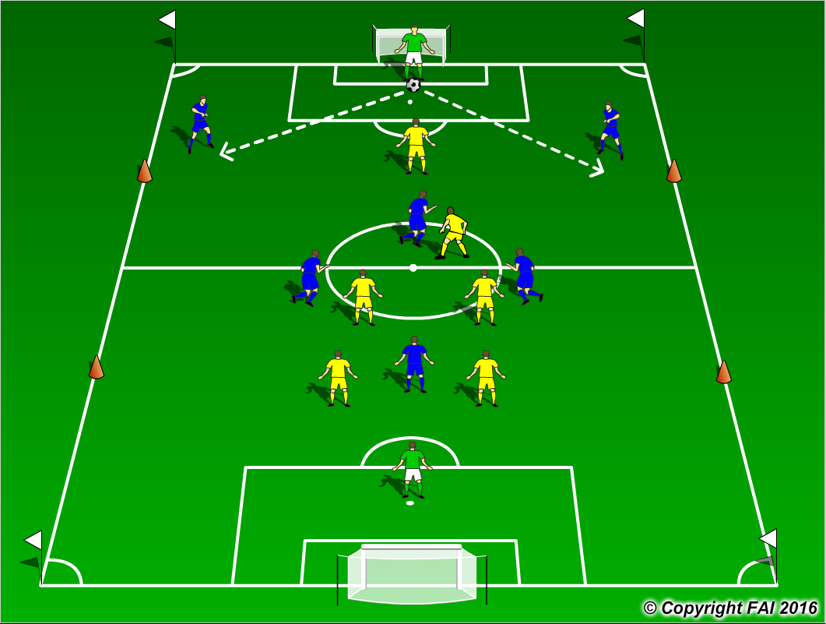

ORGANISATION
- Area: 60 metres x 40 metres
- 7 v 7 Game: Blue Team 1.2.3.1 v Yellow Team 1.2.3.1
- Supply of balls in each goal
- Offside’s in the Thirds, marked by cones
- Goalkeeper starts the play at all times with the ball in the middle of 6 yard box
- When Goalkeeper is restarting play only 1 opposition player is allowed to enter that third

KEY FACTORS
- Starting positions of Defenders – wide and high, open body shape, awareness and receive on back foot
- Midfield with Holding Midfielder (6) and 2 Advanced Midfielders (8 & 10)
- Quality and selection of pass
- First touch and body shape (opened looking to play forward)
- Angles and distance of support
- Awareness and communication
- Transition to defend if ball is lost, can they win it back as quickly as possible (Pressing as a unit)

NOTES
Goalkeeper’s role very important, Quality of passing and decision making crucial. Look for high tempo

