THEME
Possession 3 v 1 into 4 v 4 Attack with Transition

DESCRIPTION OF PRACTICE (TECHNIQUE / SKILL)
A functional practice designed to improve players passing, movement, decision making, finishing and transition to defending

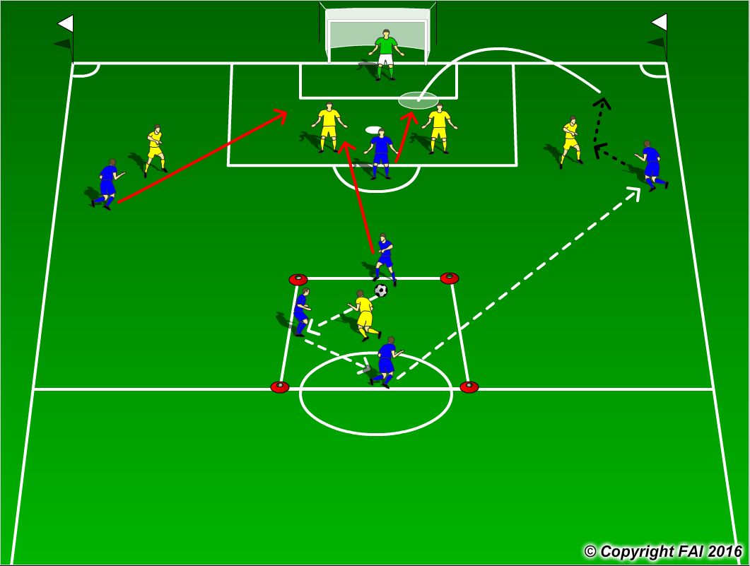

ORGANISATION
- Area: 3 v 1 - 12 x 12 metres into full width of pitch
- 3 Blue Players v 1 Yellow player into 4 Blue players v 4 Yellow players Defenders + Goalkeeper
- Blue Team start with possession and complete 5 passes to make pass outside 3 v 1 area, 1 Blue player can leave 3 v 1 area to join in the Attack with 3 Blues (2 Wingers and Center Forward)
- If the Yellow players win the ball they must try to pass the ball into the yellow player in the 3 v 1 Area, the 2 remain Blues in this area cannot stop this, when the 4 Blues attacking lose the ball they must quickly transition to Defend to try and stop this

KEY FACTORS
3 v 1 Possession
- Quality and selection of pass - Body shape/First Touch/Back Foot -Disguise/Change of Direction
- Angles and Distance of support - Awareness of space and defender - Communication between players
4 v 4 Attacking
- Attack Defenders at pace - Penetrate opposition through 1 v 1’s or combination play
- Movement for crosses be unpredictable – Transition to Defend quickly

NOTES
Movement in the box key, don’t be in too early, play off defenders shoulders on blindside

