THEME
1 v 2 Defending 1 Defender recovering with Transition

DESCRIPTION OF PRACTICE (TECHNIQUE / SKILL)
A functional practice designed to improve players 1 v 2 Defending – Pressure, Recovery runs and Cover

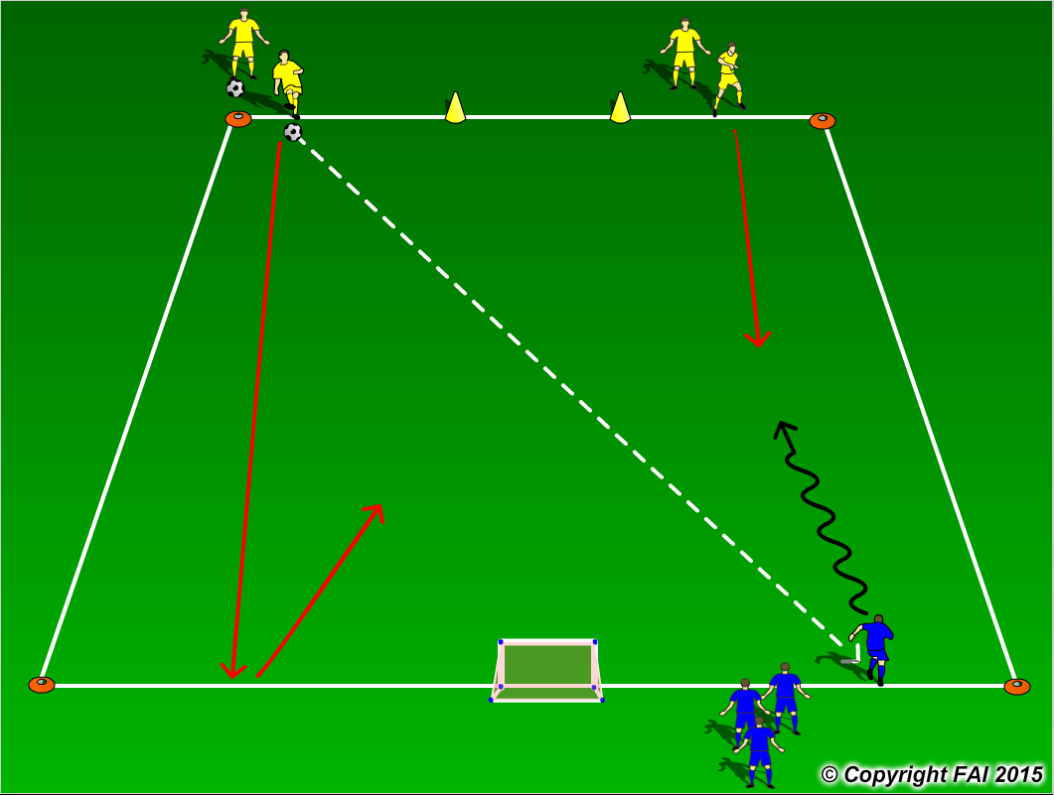

ORGANISATION
- Area 18 x 12 metres
- Yellow players (Defenders) pass the ball to the Blue players (Attackers), nearest Yellow Defender comes and Defends, Defender that played original pass must run to opposite line and then recover to help 1st Defender
- Blue player has to score by dribbling through the gate marked by cones, if the Yellow players win the ball they can score by passing the ball into the small goal at the opposite end

KEY FACTORS
- Close down quickly, but under control
- As first Defender travels to close down Attacker – assess Attackers first touch
1. Poor 1st touch – win the ball 2. Good 1st touch delay
- Body shape/stance – low, side on
- Jockey, delay – be patient wait for opportunity to win the ball
- Second Defender to recovery quickly – speed, then defenders to press and cover
- Quick Transition in Attack on winning possession

NOTES
Make sure that players play till goal is scored or ball goes out of play and are aware of the Transitions

