THEME
5 v 3 Zonal Possession with transition

DESCRIPTION OF PRACTICE (TECHNIQUE / SKILL)
A Practice designed to improve players passing, movement and positioning with transition

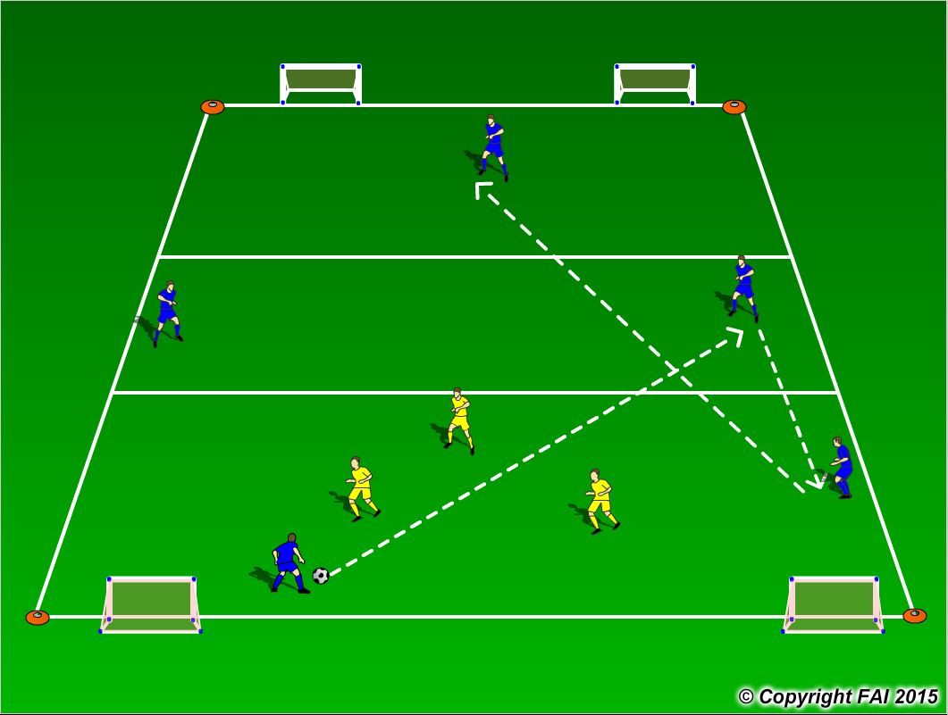

ORGANISATION
- Area: 30 x 15 metres (3 zones, each 10 x 15 metres)
- Two teams: 5 Blues and 3 Yellows
- Blue players must stay in their zones as seen above in diagram while the 3 Yellow players can enter any zone
- Blue team start the practice with emphasis on keeping possession through the zones
- Utilize playing positions - movement from training to game
- If the Yellow team win the ball they must attempt to score in any of four small goals while the blue team must transition to defend quickly and try and win the ball back – Blue players can leave zones on defending (6 second rule)
- Have a supply of footballs to keep the practice continually flowing

KEY FACTORS
- Quality and selection of pass
- First touch/Body shape
- Angles and Distance of support
- Awareness of space and defender
- Transition to attack and defense

NOTES
Keep intensity levels high. If blues kick the ball out of play, Coach gives Yellow team possession. If players of good quality encourage two touch

