THEME
1 v 1 Attacking and Defending

DESCRIPTION OF PRACTICE (TECHNIQUE / SKILL)
A functional practice designed to improve players 1 v 1 Attacking and Transition to Defend

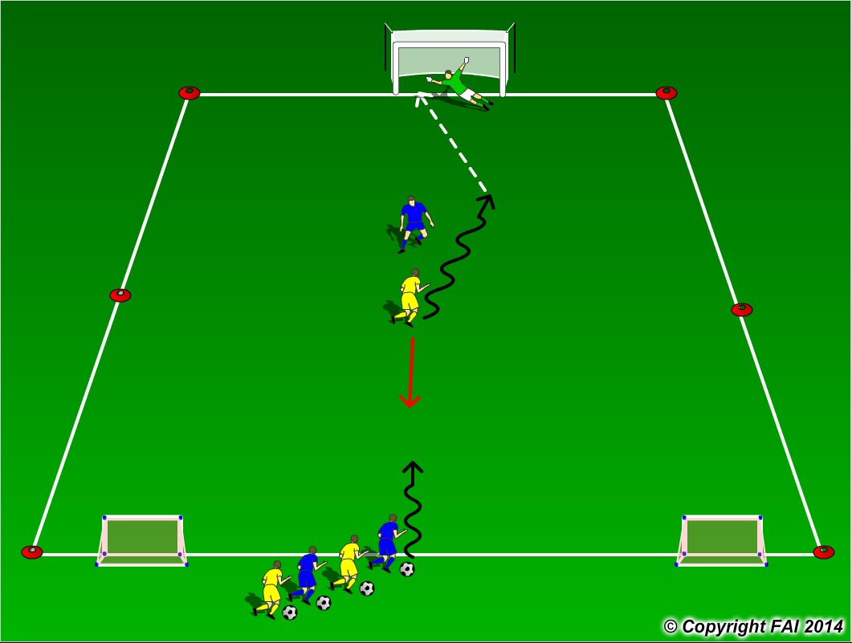

ORGANISATION
- Area 15 x 20 metres
- Yellow Player Attacks Blue player when a goal is scored or the ball goes out of play, the Yellow player now becomes a Defender and the next Blue player is the Attacker
- If the defender or goalkeeper win’s the ball they can pass through the two small goals to score

KEY FACTORS
- Positive first touch, get the ball out of your feet
- Attack the defender with the ball under control
- Keep your head up to assess defender and goalkeepers position
- Make your move (Skill, trick or speed)
- Accelerate into space created
- End Product
- Transition to Defend quickly but under control

NOTES
Encourage players to be creative, attack at speed and play until Goal is scored or ball is out of play

