THEME
Possession 5 v 3 with transition

DESCRIPTION OF PRACTICE (TECHNIQUE / SKILL)
A Practice designed to improve players passing, movement and transition to attack/defense

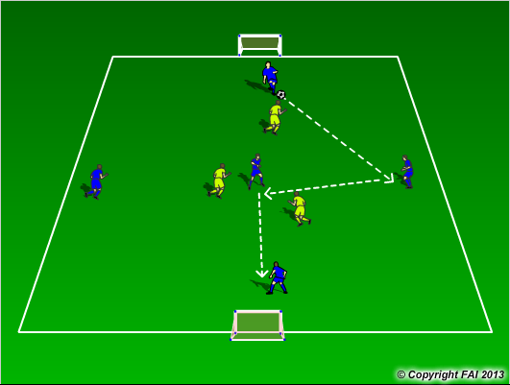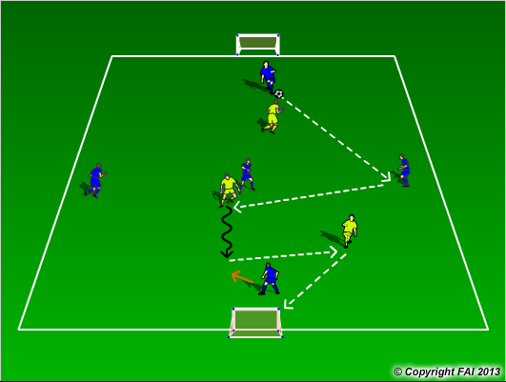

ORGANISATION
- Area: 30 x 15 metres
- Two teams: 5 Blues and 3 Yellows
- Blues start with possession and try and keep ball from the yellows (Diagram 1)
- Utilize the central blue player to change direction of play
- If the Yellows win the ball, they can score in either of the two small goals. The blues must transition to defend quickly and try and win the ball back (Diagram 2)

KEY FACTORS
- Quality and selection of pass
- First touch/Body shape – very important for central blue player
- Angles and Distance of support
- Awareness of space and defender
- Transition to attack for Yellow’s , to defend for the blues

NOTES
Coach can have supply of balls on the outside, if blues kick the ball out of play. Coach give yellow players possession

