THEME
4-3-3 Positional Rondo

DESCRIPTION OF PRACTICE (TECHNIQUE / SKILL)
A Practice designed to improve players passing, positioning, decision making and movement with transition to defend within a 4-3-3 playing formation

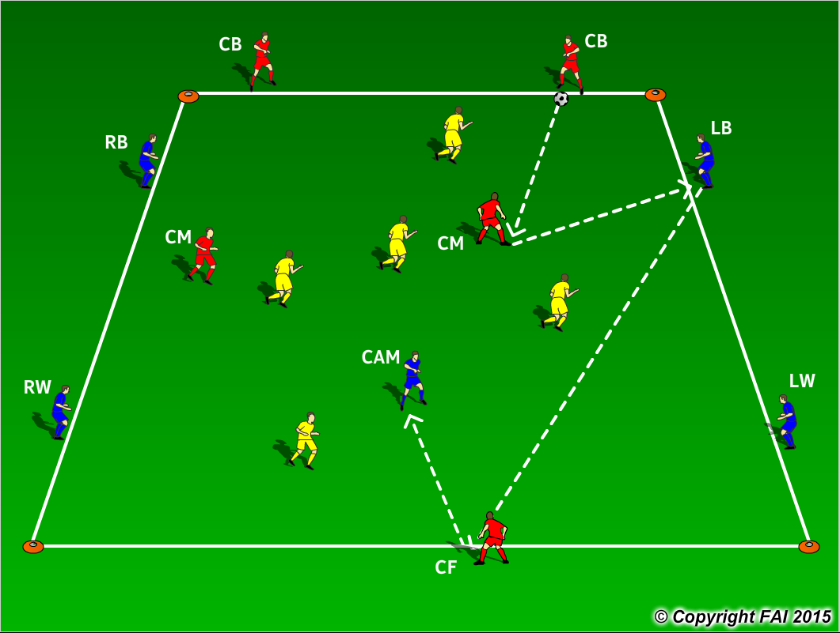

ORGANISATION
- Area: 40 x 35 metres
- 5 Blues + 5 Reds v 5 Yellows
- Blues (attacking) v Yellows (defending) compete to maintain possession using the neutral players (Reds) to combine with when in possession.
- If the Yellow team wins the football from the Blue team, they must switch positions. Yellows transition from defense to attack while Blue team now transition from attack to defense.
- When not in Possession Blues/Yellows can leave their position and press to win the ball back
- Have a supply of footballs to keep the practice continually flowing
- Play for 5 minutes with a 1 minute rest period

KEY FACTORS
- Quality and selection of pass
- First touch/Body shape/Receive on Back Foot
- Angles and Distance of support – triangle/diamond shapes
- Width and depth – Penetrating Pass
- Awareness of space and defender
- Decision Making – speed of thought
- Transition to Defend – can we win ball back as quickly as possible
- Transition to Attack – width and depth as quickly as possible

NOTES
Demand high quality. If players of a high ability play one/ two touch football. Modify to play with two CAM’s

