THEME
Possession 4 v 2 into 5 v 5 Attack with Transition

DESCRIPTION OF PRACTICE (TECHNIQUE / SKILL)
A functional practice designed to improve players passing, movement, decision making, finishing and Transition to Defending

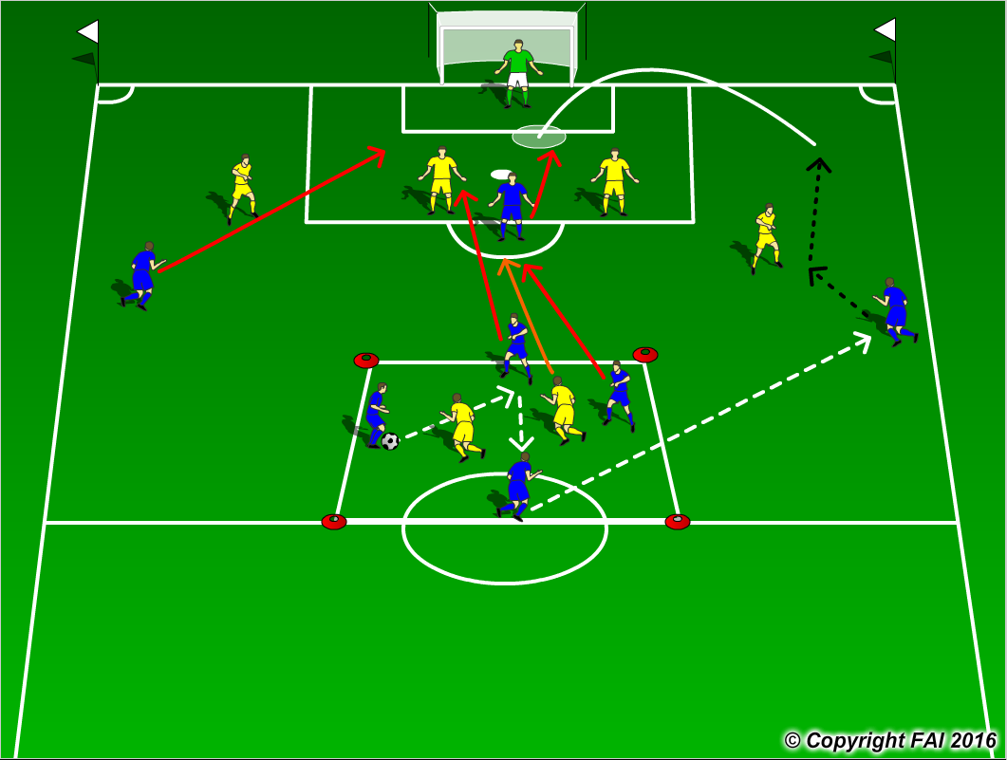

ORGANISATION
- Area: 4 v 2 - 15 x 15 metres into full width of pitch
- 4 Blue Players v 2 Yellow players into 5 Blue players v 5 Yellow players Defenders + Goalkeeper
- Blue Team start with possession and complete 5 passes to make pass outside 4 v 2 area, 2 Blue players can leave 4 v 2 area to join in the Attack with 3 Blues (2 Wingers and Center Forward), one Yellow player can also leave the area to Defend
- If the Yellow players win the ball they must try to pass the ball into the Yellow player in the 4 v 2 Area, the 2 remaining Blues in this area cannot stop this, when the 5 Blues attacking lose the ball they must quickly transition to Defend to try and stop this

KEY FACTORS
4 v 2 Possession
- Quality and selection of pass - Body shape/First Touch/Back Foot -Disguise/Change of Direction
- Angles and Distance of support - Awareness of space and defender - Communication between players
5 v 5 Attacking
- Attack Defenders at pace - Penetrate opposition through 1 v 1’s or combination play
- Movement for crosses be unpredictable – Transition to Defend quickly

NOTES
Movement in the box key, don’t be in too early, play off defenders shoulders on blindside

