THEME
Possession 4 v 2 with transition

DESCRIPTION OF PRACTICE (TECHNIQUE / SKILL)
A Practice designed to improve players passing and movement and transition to defending

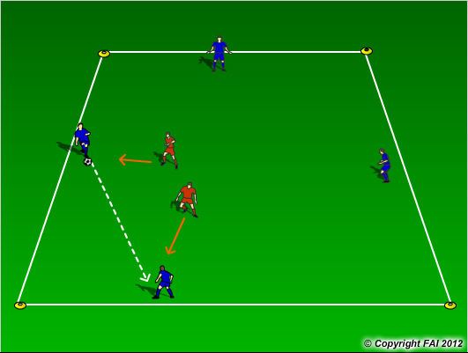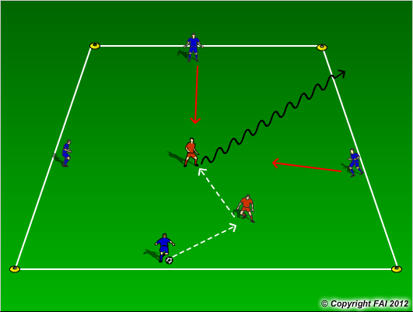

ORGANISATION
- Area: 15 x15 metres
- 4 Blues v 2 Reds
- Blues start with possession and try and keep ball from the Red players (Diagram 1)
- If the reds win the ball, the red player must try combine and then dribbling outside the grid (Diagram 2)
- If blue players give the ball away, they must react quickly to win the ball back.

KEY FACTORS
- Quality and selection of pass – Back Foot
- First touch/Body shape
- Angles and Distance of support
- Width and depth – Penetrating Pass
- Awareness of space and defender
- Transition to Defend – can we win ball back as quickly as possible

NOTES
Demand high quality. If players of a high ability play two touch

