THEME
Attacking with Midfield 3 and Forward with transition to defend

DESCRIPTION OF PRACTICE (TECHNIQUE / SKILL)
Phase of Play practice designed to improve the combinations and movement of the Midfield and Forward based on a 7 v 7 Small Sided Game with formation 1.2.3.1

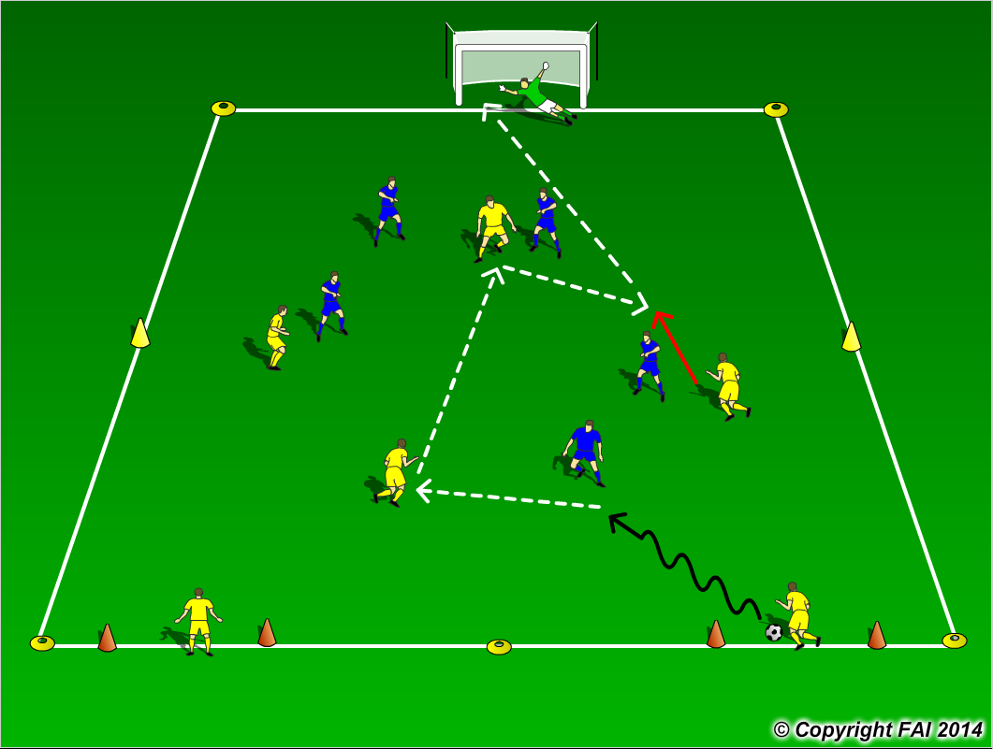

ORGANISATION
- Area: 40 metres x 35 metres
- In Yellow 3 Midfielders + 1 Forward V In Blue Goalkeeper + 2 Defenders + 3 Midfielders
- 2 Target Yellow players standing in the gates
- Yellow team attack the Goal, Blue team in possession must score by playing the ball to one of 2 Yellow target players in gates, they can then join in the attack (Center Backs)

KEY FACTORS
- Starting Positions – Midfield 3 one Holding Midfielder (6) and 2 advanced Midfielders (8 & 10), Center Forward in between Center Backs
- Midfielder’s movement to receive, look to play forward, open body shape.
- Quality of pass, accuracy and pace
- Players looking to receive ball in between and behind opposition
- Use combination play to create scoring opportunities
- Transition to defend can we win it back as quickly as possible? As high up as possible?

NOTES
Let players make their own decision, look for high tempo, make sure midfielders aren’t crowding space by running towards the player in possession, taking away space. Yellow target act as Center Backs (create 4v3 in Midfield)

