THEME
1 v 1 Turning and Running with the Ball

DESCRIPTION OF PRACTICE (TECHNIQUE / SKILL)
A functional practice designed to improve players 1 v 1 Turning and Running with the ball with Transition to Defend

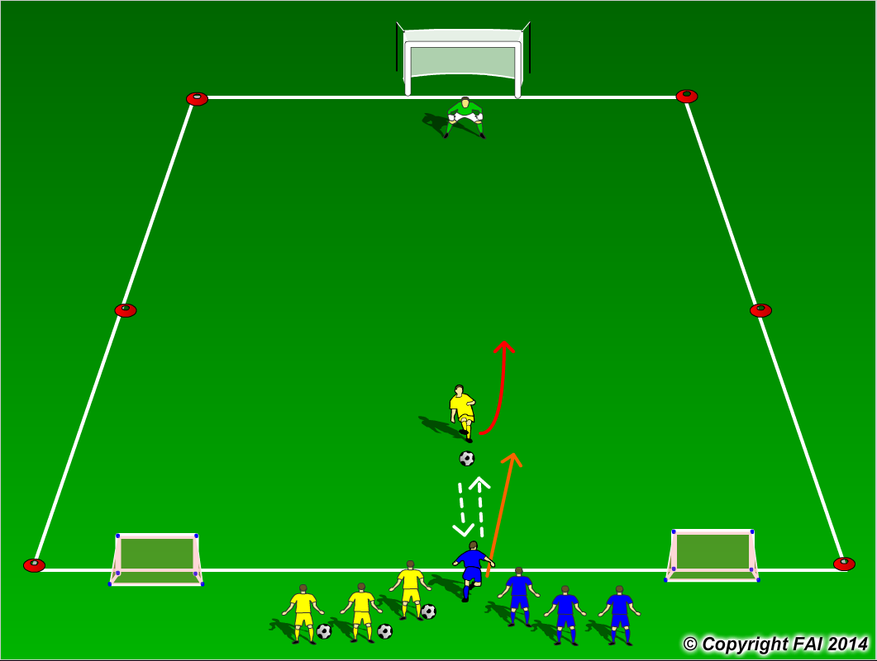

ORGANISATION
- Area 20 x 15 metres
- Yellow Player (Attacker) passes back and forth with one touch to Blue Player (Defender)
- On Yellow players decision he/she turns and attacks the goal, Blue player must react and defend
- If the Goalkeeper saves the ball or the blue player wins the ball, they must then transition to attack and try to score In the two small goals
- Players switch roles after each go

KEY FACTORS
- Quick turn - minimum touches, feints or let the ball run through legs
- Positive first touch, get the ball out of the players feet
- Running with the ball – big touches but under control
- Keep body between Ball and Defender
- Keep head up to assess Goalkeepers position
- End Product

NOTES
Encourage players to be creative, attack at speed and play until Goal is scored or ball is out of play

