THEME
Technical Passing Warm Up

DESCRIPTION OF PRACTICE (TECHNIQUE / SKILL)
A practice designed to improve players speed of passing, movement and dribbling

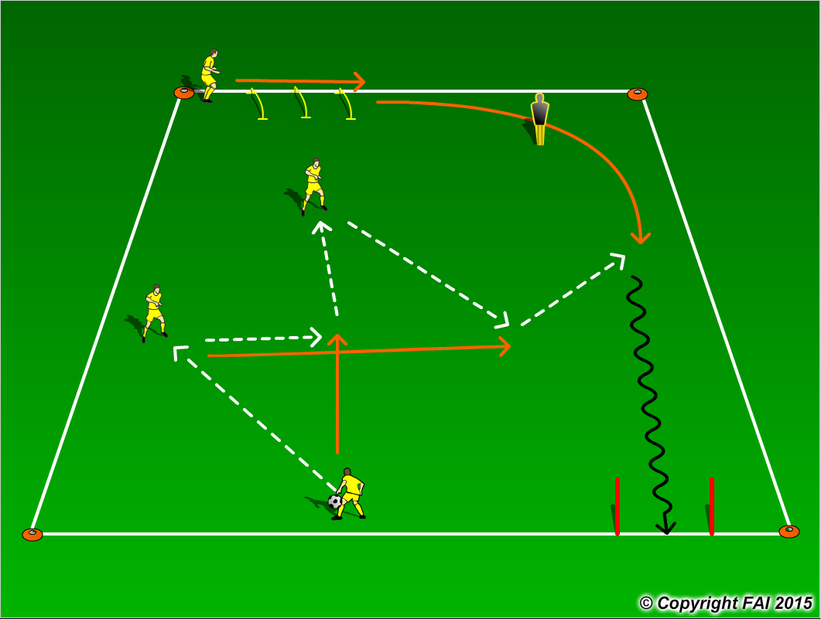

ORGANISATION
- Area: 24x24 metres
- 4 players in a group
- On Coaches signal group of players start
- Players to play one touch with passes
- Player that receives the ball to dribble must be running onto pass in time
- Players rotate after each sequence till all players have performed in each position

KEY FACTORS
- Quality of passing
- Accuracy of passing
- Quickness of passing, movement and dribbling
- Communication – support of teammates
- 100% effort with and without the ball

NOTES
Watch each players pass, movement and touch performed at speed. Demand high tempo from players

