THEME
Attacking with Goalkeeper, Back 4 and Midfield 1 with Transition to Defend

DESCRIPTION OF PRACTICE (TECHNIQUE / SKILL)
Phase of Play practice designed to improve players Technical and Tactical Awareness when playing out from the back

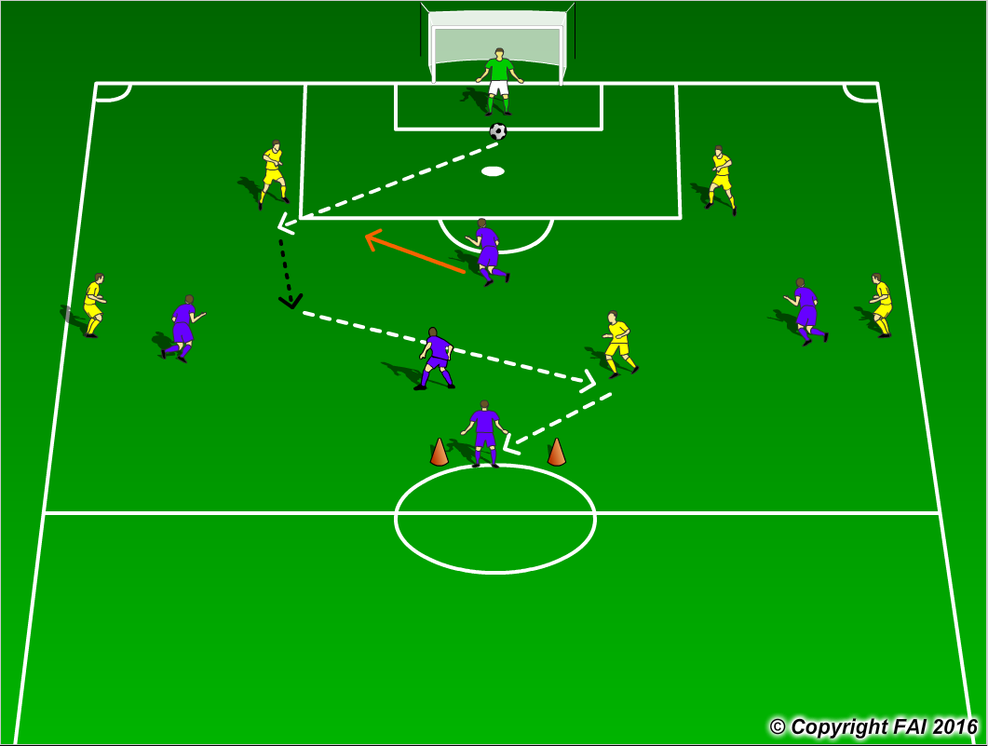

ORGANISATION
- Area: Full Width of the pitch and 1 Gate positioned at the top of Center circle
- In Yellow: Goalkeeper + 4 Defenders + 1 Midfielder v in Blue 1 Midfielder + 3 Attackers
- 1 Target Blue player standing behind cones
- Goalkeeper starts the play at all times with the ball in the middle of 6 yard box
- Yellow team looking to build from the back and score through the gate to the Blue target player, that then Attack Yellows goal, Yellow Team must quickly Transition to Defend

KEY FACTORS
- Starting positions of Center Backs – edge of 18 yard box, Full backs pushed high up near touchline
- Encourage Defenders if they have space to travel with the ball (as per diagram)
- Midfielder looking to receive possession opened out and in position to play forward
- Quality and selection of pass
- First touch and body shape (opened looking to play forward)
- Angles and distance of support – make sure Midfielder plays at angles and at a good distance
- Awareness and communication
- Transition to Defend, if Yellow Teams scores through target goals or lose the ball in build up, can they win it back as quickly as possible (Pressing)

NOTES
Get the Blue team to drop off and put on limited pressure at the start to get the blue team comfortable in possession. Goalkeeper’s role very important, Quality of passing and decision making crucial

