THEME
Possession 6 v 4 with transition

DESCRIPTION OF PRACTICE (TECHNIQUE / SKILL)
A Practice designed to improve players passing, movement, decision making and transition to defending

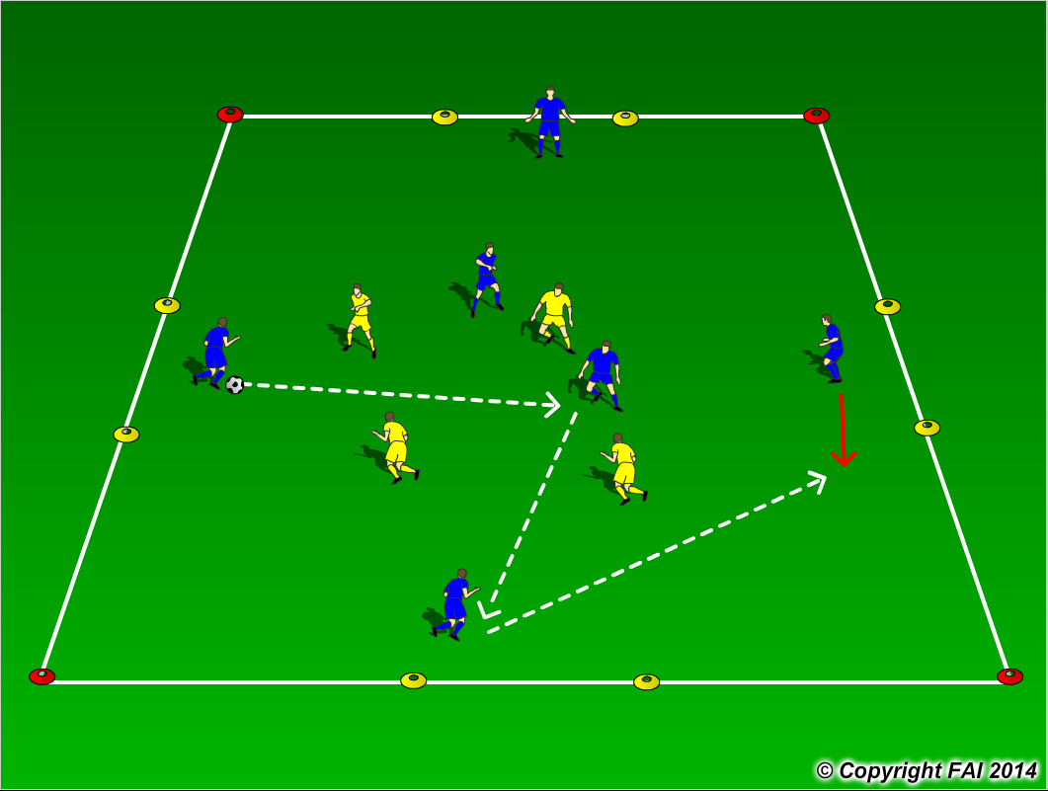

ORGANISATION
- Area: 30 x 20 metres
- 6 Blues V 4 Yellows, 2 Blues play in the middle of grid
- Blues start with possession and try and keep ball from the Yellow Players
- If the Yellow players win the ball, they can score by passing the ball through any of the 4 gates marked with Yellow cones, Blue players must transition to defend and try and win the ball back

KEY FACTORS
- Quality and selection of pass
- Body shape/First Touch/Back Foot
- Disguise/Change of Direction
- Angles and Distance of support
- Width and depth – Penetrating Pass
- Awareness of space and defender
- Communication between players
- Transition to Defend – can we win ball back as quickly as possible

NOTES
Have supply of balls outside area, to keep the tempo high. Encourage Creativity when closed down to find space, Feints/Tricks/Disguise.

