THEME
1 v 1 Dribbling with Transition to Defend

DESCRIPTION OF PRACTICE (TECHNIQUE / SKILL)
A Practice designed to improve players 1 v 1 Dribbling with Transition to Defend

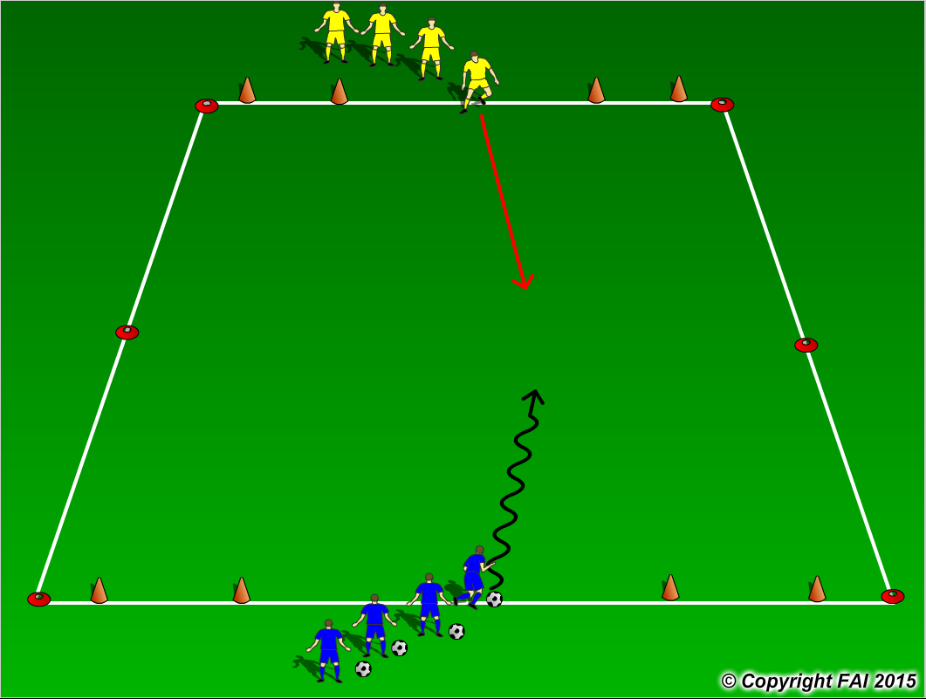

ORGANISATION
- Area 15 x 20 metres
- 4 Goals – two for Blue players to attack and 2 for Yellow players to attack, to score a goal players must dribble through the goals
- Blues (Attackers) must dribble and try to score in either of the two top goals, If the Yellows (Defenders) win the ball they can try and score in either of the two opposite goals

KEY FACTORS
- Positive first touch, get the ball out of your feet
- Attack the defender with the ball under control
- Keep your head up to assess defenders position
- Make your move (Skill, trick or speed)
- Accelerate into space created
- Transition to Defend quickly but under control

NOTES
Encourage players to be creative, attack at speed. Make sure that players play till goal is scored, i.e. goal is scored or ball goes out of play and are aware of the transitions

