THEME
Passing and Receiving

DESCRIPTION OF PRACTICE (TECHNIQUE / SKILL)
A technical practice to improve players passing, receiving and opening out onto their back foot

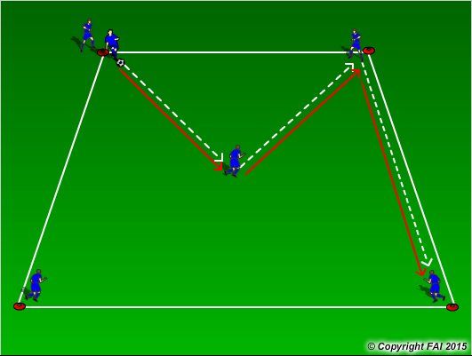

ORGANISATION
- Area: 15 x 15 metres
- 6 players, 2 players on the corner that the practice starts (Always start with 2 players at the same cone) 3 players on the other 3 corners and 1 player in the middle of the area
- 1 Football - players pass the ball (as per diagram) and follow their pass, players can pass into the middle or to their right or left

KEY FACTORS
- Quality of the pass – accuracy, pace, weight
- Two touch – one to control, second to pass or can they play on one touch, their decision
- Opened body shape to receive and control pass on back foot
- Communication
- Pass to feet or space

NOTES
Can introduce two footballs once players get an understanding of the practice, but again must be two players and football at the starting cones

