THEME
Attacking with Transition to Defend – Midfielders and Attackers

DESCRIPTION OF PRACTICE (TECHNIQUE / SKILL)
9 v 9 Small Sided Game designed to improve the combinations and movement of the Midfield and Attackers

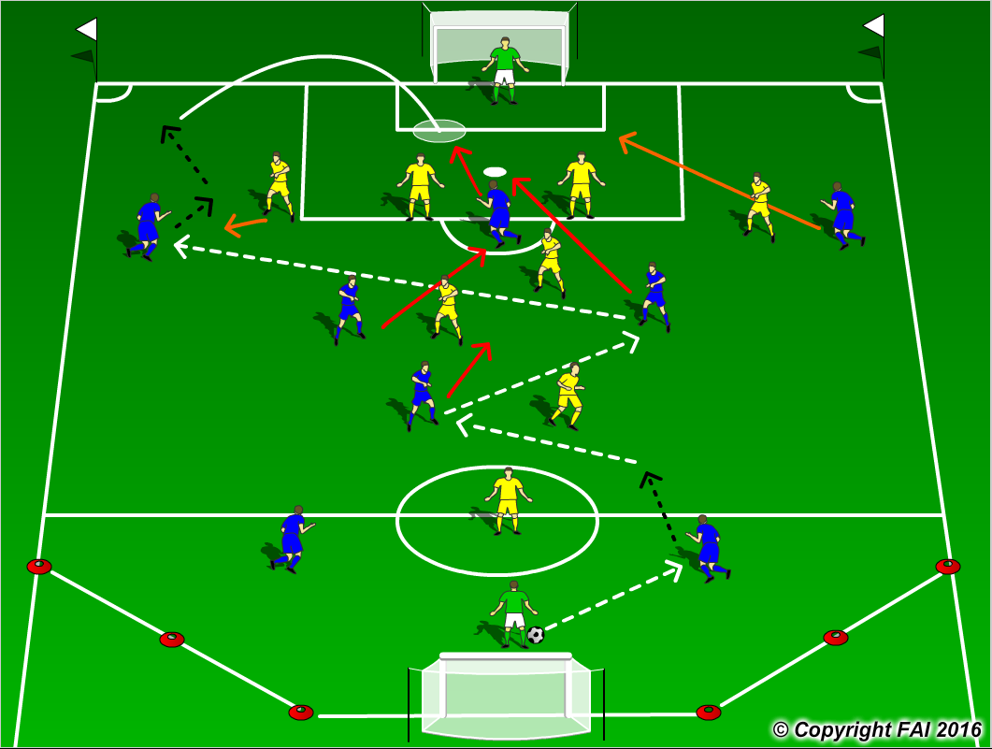

ORGANISATION
- Area: Full width of pitch, length end line to 18 yard box. Cut off the sides on one end
- 9 v 9 Game: Blue Team 1.2.3.3 V Yellow Team 1.4.3.1
- Supply of balls in each goal
- Goalkeeper starts the play at all times with the ball in the middle of 6 yard box

KEY FACTORS
- Starting Positions – Defenders spread out to receive pass from Goalkeeper, Midfield 3 one Holding Midfielder (6) and 2 Advanced Midfielders (8 & 10), Wingers wide and Center Forward in between Center Backs
- Midfielder’s movement to receive, look to play forward, open body shape.
- Quality of pass, accuracy and pace
- Players looking to receive ball in between and behind opposition
- Encourage 1 v 1’s in Wide areas
- Position for crosses as per picture – Center Forward near post, one Midfielder on penalty spot, one just outside area and one holding, opposite Winger back post
- Transition to Defend can we win it back as quickly as possible? As high up as possible?

NOTES
Let players make their own decision, look for high tempo, make sure midfielders aren’t crowding space by running towards the player in possession, taking away space. Encourage Blue Center Backs to create 4 v 3 in Midfield

