THEME
Passing at angles

DESCRIPTION OF PRACTICE (TECHNIQUE / SKILL)
A practice to improve players passing at angles and opening out on back foot

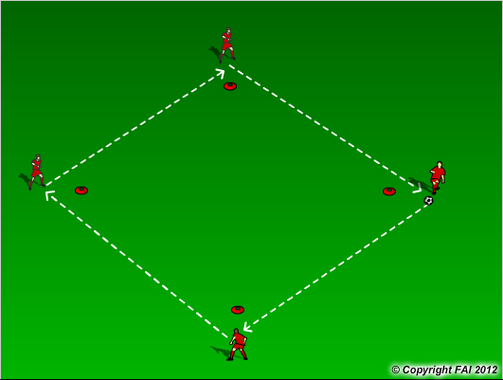

ORGANISATION
- Area: 15 x 15 metres
- 4 players per area, 4 standing 1 meter back from red cones
- 1 Ball - players pass the ball (as per diagram)

KEY FACTORS
- Quality of the pass – accuracy, pace, weight
- Two touch – one to control, second to pass
- Control pass on back foot
- Communication
- Receiving players movement – treat cone as player, come off at an angle, opened body shape

NOTES
Change direction of practice so players work with both feet. Look for high quality

