THEME
Positional Possession 6 v 6 + 2

DESCRIPTION OF PRACTICE (TECHNIQUE / SKILL)
A practice designed to improve players passing, decision making , movement and transition play

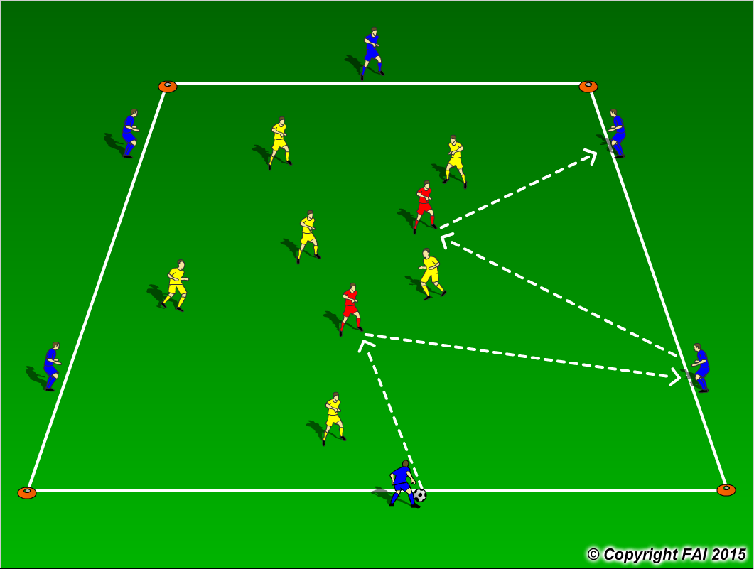

ORGANISATION
- Area: 40 x 30 metres
- 6 Blues v 6 Yellows + 2 Reds
- When in possession Blue team play in the shape as seen in diagram above, if the Yellow team win possession they play in this shape also.
- Red players always play with team in possession, both players play inside the area – ‘Xavi’ and ‘Iniesta’ role.
- When not in Possession Blues/Yellows can leave their position and press to win the ball back as seen above in the diagram
- Have a supply of footballs to keep the practice continually flowing

KEY FACTORS
- Quality and selection of pass
- First touch/Body shape /Back Foot
- Angles and Distance of support
- Width and depth – Penetrating Pass
- Awareness of space and defender
- Transition to Defend – can we win ball back as quickly as possible
- Transition to Attack – width and depth as quickly as possible

NOTES
Demand high quality. If players of a high ability play two touch

