THEME
Crossing and Finishing unopposed practice

DESCRIPTION OF PRACTICE (TECHNIQUE / SKILL)
A technical practice designed to improve players Crossing and Finishing

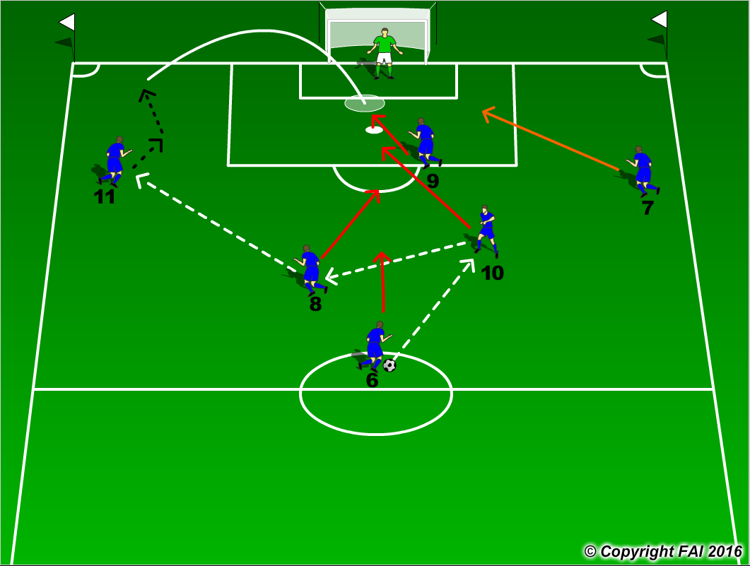

ORGANISATION
- Area half full size pitch
- Players in position as per diagram
- Supply of footballs

KEY FACTORS
- Movement to receive pass
- Quality of pass – to feet or space
- Quality of crossing – at pace, few touches
- First time finish or lay off for teammate
- Movement in box no.9 near post, no.10 penalty spot, no. 7/11 back post, no.8 outside box, no.6 holds

NOTES
Demand high quality as it is an unopposed practice. Movement and passing done at a high intensity

