THEME
Attacking Through The Thirds with Transition

DESCRIPTION OF PRACTICE (TECHNIQUE / SKILL)
A practice designed to help break down a defensive set up who sit deep with transition

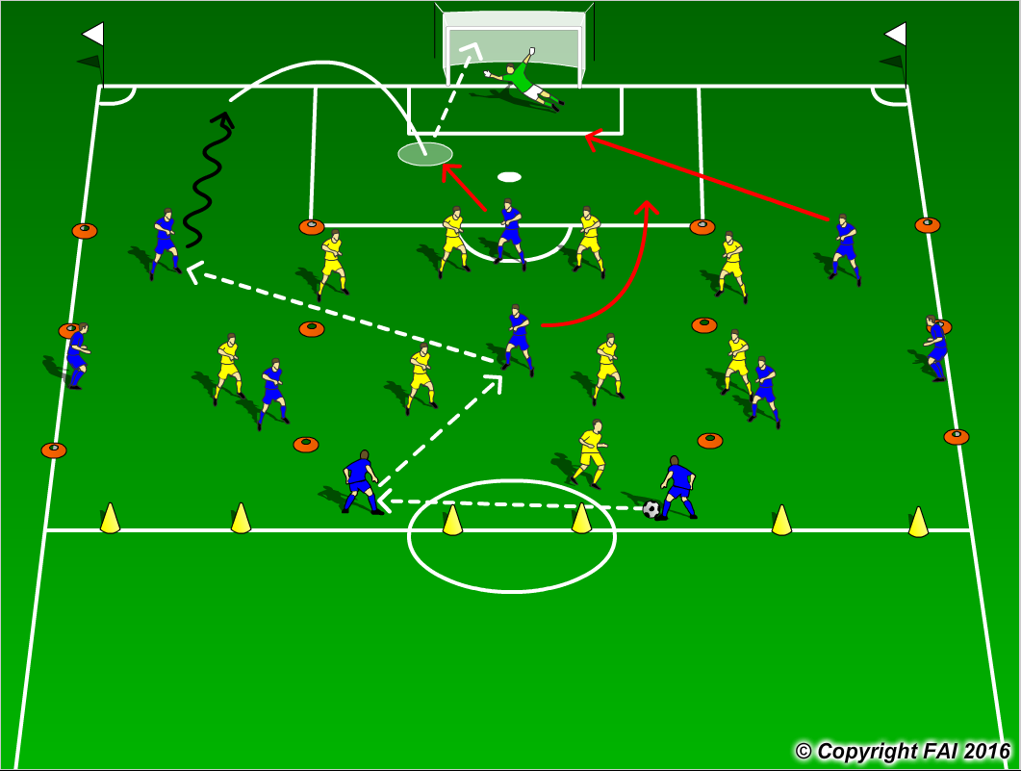

ORGANISATION
- Area: Full Width of the pitch with 4 zones and 3 Gates positioned 5 metres along halfway line
- 10 Blues v 9 Yellows + Goalkeeper. Players to stay in their zones up until Zone 4
- Zone 1: 2 Blues v 1 Yellow, Zone 2: 5 Blues v 4 Yellows, Zone 3: 3 Blues v 4 Yellows, Zone 4: 0 Blues v Yellow Goalkeeper
- Blue team attack the goal whilst building up through the thirds, Yellow team attempt to stop Blue team and when in possession must score by playing the ball through one of the 3 Yellow gates. Yellow players when in attack can leave their zones.
- When Blue team get into Zone 4, players can enter that zone but Blue team must be mindful of transition to defend if Yellow team gain possession.

KEY FACTORS
- Starting Positions – width and depth in each zone, looking to play in between and behind the lines
- Midfielder’s movement to receive, look to play forward, open body shape – play in the halfspaces
- Quality of pass, accuracy and pace
- Encourage 1 v 1’s in wide areas in Zone 3
- Communication between units and patience on the ball
- When players in Zone 4, encourage players to be creative in their decision making and movement
- Transition to defend can we win the ball back as quickly as possible as high up as possible

NOTES
Let players make their own decision. Encourage players to play one/two touch with the ball rotating at all times. Make sure players aren’t crowding space by running towards the player in possession, taking away space.

