THEME
1 v 1 Dribbling and Finishing with Transition to Defend

DESCRIPTION OF PRACTICE (TECHNIQUE / SKILL)
A functional practice designed to improve players 1 v 1 dribbling and finishing with Transition to Defend

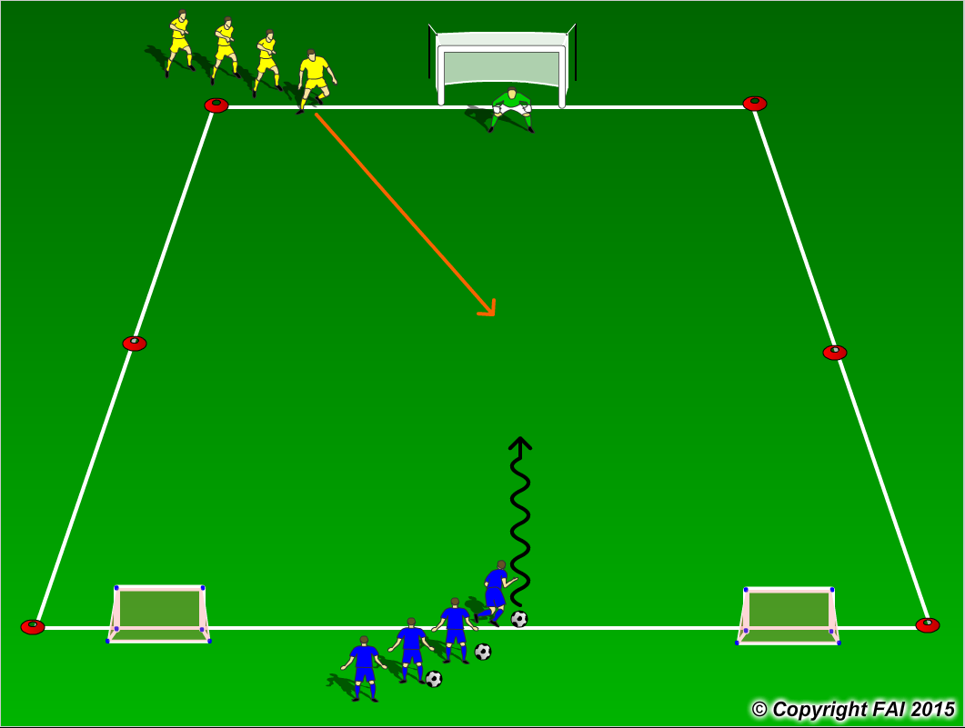

ORGANISATION
- Area 15 x 20 metres
- Blue player attacks the main goal and the Yellow Player and Goalkeeper try to prevent goals and if they win possession they must counter quickly and score through the two small goals at the other end

KEY FACTORS
- Positive first touch, get the ball out of your feet
- Attack the defender with the ball under control
- Keep your head up to assess defender and goalkeepers position
- Make your move (Skill, trick or speed)
- Accelerate into space created
- Quality finishing
- Blue players don’t always need to beat Yellow player to score, can finish by curling around them or feinting to shoot high and then shoot low (Creativity)

NOTES
Encourage players to be creative, attack at speed. Make sure that players play till goal is scored, i.e. goal is scored or ball goes out of play and are aware of the transitions

